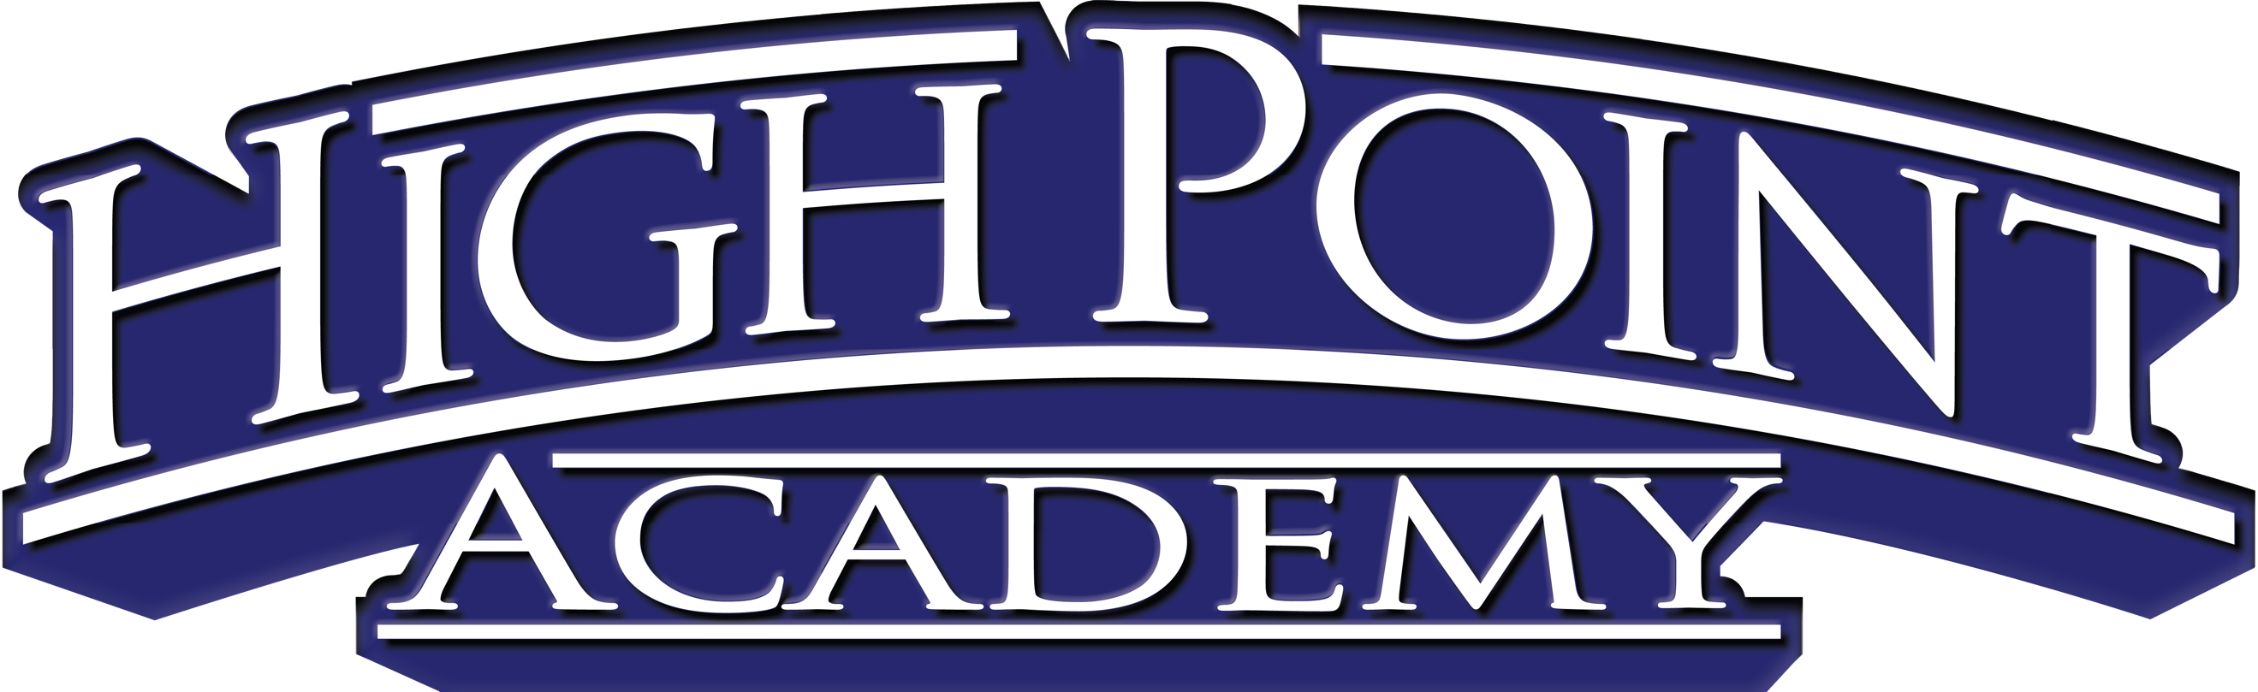

Written Procedure for Processing Parent Suggestions
Federal Programs

Dear HPA Families,

Comments and suggestions made by parents/guardian are important to the planning, design, and implementation of the Federal Programs at High Point Academy Spartanburg. Parents can make comments, ask questions, and make suggestions by going to our school website at https://hpaspartanburg.com/contact-us/, calling the main office directly at 864-316-9788, or contacting the Director of Federal Programs, Christy Papala, cpapala@hpaspart.org or call 864-208-8163.

The following procedure is followed when parent comments, questions, or suggestions are received:
- Information shared with appropriate personnel, as needed
- After discussion or research of information, a decision is made regarding information received and the appropriate person provides parent(s) with a response. Responses may be provided verbally, in a meeting, via telephone, by letter, or in e-mail; as appropriate. The appropriate personnel will respond to comments, questions, and suggestions within a 24-hour time frame.
We sincerely appreciate your comments, questions, and suggestions to ensure that students are receiving the very best educational experience.

Sincerely,

Christy Papala
Director of Federal Programs
High Point Academy Spartanburg

6655 Pottery Road Spartanburg, SC 29303

